Project 9: CSS Table Styling

Objectives:

At the end of this project, you will be able to:
- Use CSS to format a table in a web page
- Set border style, thickness, and color for table elements
- Apply padding and background colors to table cells

Instructions:
- Create a new folder called "CSS Table Styling".
- Copy the five weather image files into this new folder. Your teacher will provide these files.
- Create a new XHTML document and save it as "index.html" in the "CSS Table Styling" folder.
- Edit the index.html file and set the title to be "CSS Table Styling".
- Recreate the following table as precisely as you can:

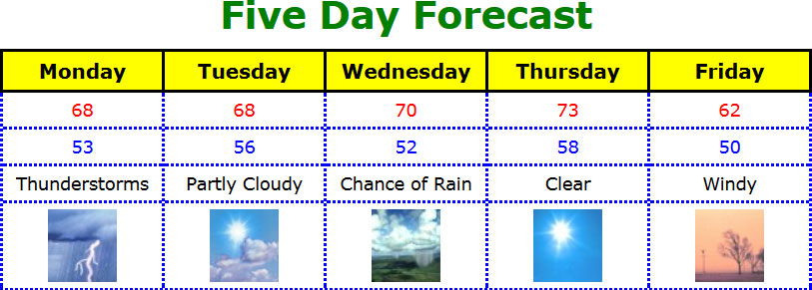

- For this project, it is okay to style some of the table elements directly (without using classes).
- Requirement #1: Use the border shorthand feature instead of the individual border properties.
- Requirement #2: The table has a total width of 650px, the columns are set by percent, and the font used throughout is called Verdana.
- Requirement #3: Use table headers for the first row and apply styles to that element.
- Requirement #4: Use separate classes for the highs and lows and apply them to the table rows.
- Hint: You will need to use all of the following properties: background-color, border, border-collapse, color, font-family, font-size, font-weight, padding, text-align, width.

Rubric 9: CSS Table Styling

Name: ____________________________

Component | Possible Points | Score
The table is 650px wide and has a border-collapse applied to it. | 3
All table elements are centered and all text is in the Verdana font. | 2
A table caption exists and has been styled near to the example. | 3
The five columns are set by percent and appear of equal width. | 3
The first table row contains table headers and has the correct border and background color. | 4
Separate classes have been defined and applied to the rows of highs and lows. | 4
The final row shows the appropriate images matching the description. | 2
Each of the <img> tags has the required alt attribute defined. | 1
The final four rows have a dotted blue border. | 3
Total Score | 25

